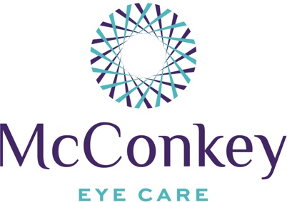

Dry Eye Tips

- Stay hydrated
- Drink water and electrolytes, not soda
- Eat more fish, specifically salmon, mackerel, anchovies, and other fish high in omega 3
- Avoid fried food and other foods high in pro-inflammatory omega 6s
- Take a Triglyceride form fish oil supplement
- Stop smoking

- Avoid drops like Visine and Clear Eyes
- Use preservative free eye drops when possible
- Do not use baby shampoo or a washcloth for hot compresses
- Avoid sleeping with a fan, otherwise, sleep with a sleep mask
- Start your car before you leave, so you do not have to blast heat or air when you get in
- Point fans and vents (especially car vents) away from you
- Take breaks from the computer
- Blink every time you turn a page in a book, open an email, take a sip of water, or stop at a stoplight
- Use a humidifier, whether whole house, space, or personal/desk sized
- Avoid known allergens (dust, pollen, dander), use high quality air filters, vacuum frequently
- Wear sunglasses outside

- Close your eyes while using a hair dryer
- Wear as little makeup around your eyes as possible
- Remove all makeup thoroughly at bedtime
- Do not put eyeliner on your “waterline”
- Avoid lash extensions
- Do not get permanent or tattoo eyeliner

- Never, and I mean never, use costume contact lenses
- Do not sleep in contact lenses
- Replace contact lenses as prescribed
- Consider daily contact lenses

1128 Baldwin Mill Road, Jarrettsville, MD 21084
4425 Fitch Avenue, Suite 120, Nottingham, MD 21236
Telephone: 443-453-5444 www.McConkeyEyeCare.com Fax: 443-453-5114
info@McConkeyEyeCare.com

